BERNARD OWUSU SEFAH

PRE-LAB 6: LAWN SPRINKLER SYSTEM

Task 1

|  |  |  |  |  |  |  |  |  |  |
| --- | --- | --- | --- | --- | --- | --- | --- | --- | --- |
| RAIN | HUMIDITY | SALINITY | MOISTURE | SYSTEM | A | B | C | D | VALUE |
| 0 | 0 | 0 | 0 | 0 | 1 | 1 | 1 | 0 | 0 |
| 0 | 0 | 0 | 0 | 1 | 1 | 0 | 1 | 1 | 1 |
| 0 | 0 | 0 | 1 | 0 | 1 | 1 | 1 | 0 | 0 |
| 0 | 0 | 0 | 1 | 1 | 1 | 0 | 1 | 1 | 1 |
| 0 | 0 | 1 | 0 | 0 | 1 | 0 | 1 | 1 | 1 |
| 0 | 0 | 1 | 0 | 1 | 1 | 0 | 1 | 1 | 1 |
| 0 | 0 | 1 | 1 | 0 | 1 | 1 | 1 | 0 | 0 |
| 0 | 0 | 1 | 1 | 1 | 1 | 1 | 1 | 0 | 1 |
| 0 | 1 | 0 | 0 | 0 | 1 | 1 | 1 | 0 | 0 |
| 0 | 1 | 0 | 0 | 1 | 1 | 1 | 1 | 0 | 0 |
| 0 | 1 | 0 | 1 | 0 | 1 | 1 | 1 | 0 | 0 |
| 0 | 1 | 0 | 1 | 1 | 1 | 1 | 1 | 0 | 0 |
| 0 | 1 | 1 | 0 | 0 | 1 | 1 | 1 | 0 | 0 |
| 0 | 1 | 1 | 0 | 1 | 1 | 1 | 1 | 0 | 0 |
| 0 | 1 | 1 | 1 | 0 | 1 | 1 | 1 | 0 | 0 |
| 0 | 1 | 1 | 1 | 1 | 1 | 1 | 1 | 0 | 0 |
| 1 | 0 | 0 | 0 | 0 | 1 | 1 | 1 | 0 | 0 |
| 1 | 0 | 0 | 0 | 1 | 1 | 1 | 1 | 0 | 0 |
| 1 | 0 | 0 | 1 | 0 | 1 | 1 | 1 | 0 | 0 |
| 1 | 0 | 0 | 1 | 1 | 1 | 1 | 1 | 0 | 0 |
| 1 | 0 | 1 | 0 | 0 | 1 | 1 | 1 | 0 | 0 |
| 1 | 0 | 1 | 0 | 1 | 1 | 1 | 1 | 0 | 0 |
| 1 | 0 | 1 | 1 | 0 | 1 | 1 | 1 | 0 | 0 |
| 1 | 0 | 1 | 1 | 1 | 1 | 1 | 1 | 0 | 0 |
| 1 | 1 | 0 | 0 | 0 | 1 | 1 | 1 | 0 | 0 |
| 1 | 1 | 0 | 0 | 1 | 1 | 1 | 1 | 0 | 0 |
| 1 | 1 | 0 | 1 | 0 | 1 | 1 | 1 | 0 | 0 |
| 1 | 1 | 0 | 1 | 1 | 1 | 1 | 1 | 0 | 0 |
| 1 | 1 | 1 | 0 | 0 | 1 | 1 | 1 | 0 | 0 |
| 1 | 1 | 1 | 0 | 1 | 1 | 1 | 1 | 0 | 0 |
| 1 | 1 | 1 | 1 | 0 | 1 | 1 | 1 | 0 | 0 |
| 1 | 1 | 1 | 1 | 1 | 1 | 1 | 1 | 0 | 0 |

A= RAIN B= H C= S D=M E=SYS

Task 2

BCD OUTPUT FOR Z

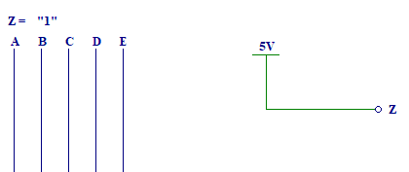

BDC OUTPUT FOR Y

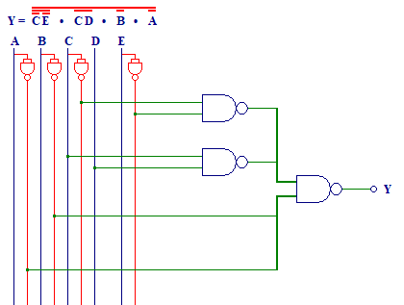

BCD OUTPUT FOR X  
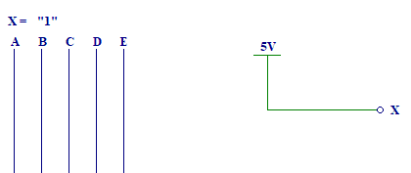

BCD OUTPUT FOR W  
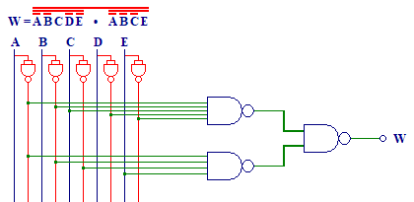

BCD OUTPUT FOR V

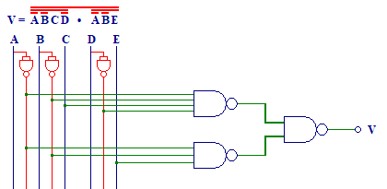

TASK 3

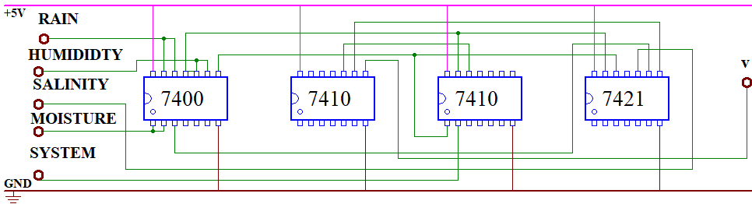

TASK 4

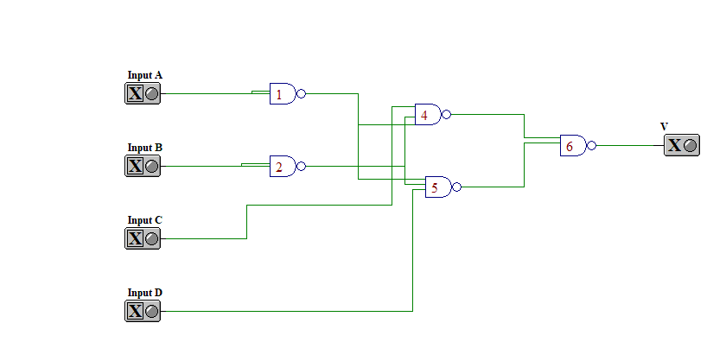

TASK 5

